9th and 10th grade – May 2, 2016
**ASIA PPT DUE MONDAY 5/2**
*all late/makeup work & corrections must be completed before April 29 for credit.
Prayer song…and the wheel says… http://wheeldecide.com/index.php?c1=Flawless&c2=Greater&c3=If+we+are+the+Body&c4=Who+am+I&c5=My+God+is+an+Awesome+God&c6=Soul+on+Fire&c7=Happy&c8=You+Raise+me+Up&c9=Ave+Maria%28Celine+Dion%29&c10=Ave+Maria%28Andrea+Bocelli%29&time=5
News: Work for 30 minutes per subject – then mark your time and move on to another subject. You may come back if you need to…TIME STARTS WHEN YOU START THE FIRST PROBLEM …PENCIL TO PAPER…getting ready does not count.
I RECOMMEND YOU SET A TIMER.
MATH TESTS = MONDAYS
SCIENCE TESTS = FRIDAYS
GEOGRAPHY TESTS = THURSDAYS for now…
EVERY WEEK … NBQUIZ/quiz = ANY DAY
GLOGS DUE EVERY MONDAY!!
Tests may need to be on other days if we are not quite ready on that day.
Geometry 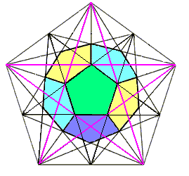
===============================
Let’s grade HW(AON) then put on your GLOG!
Any from the back of the book that are not already checked prior to class are wrong.
HW WAS: 1=READ LESSON 11.1
2=DEFINE VOCAB IN YOUR SPIRAL = 6
DEFINE = TERM+DEFINITION+DRAWING+ ALGEBRAIC EXAMPLE
WRITE IN YOUR BEST HANDWRITING
FOR THE DRAWINGS YOU MAY PRINT AND CUT AND PASTE INTO SPIRAL…
3=DO CHECKPOINT 1,2 ON PAGE 590
GO! due Monday
Sess = show every single step = sess
Let’s grade – two separate grades:
REMEMBER – GLOGS – DUE Monday…else=0
REMEMBER TO MARK EVERY 30 MIN.
11.1 = CHKPT
1. CHORD – DE; JK; FH
SECANT – JK
TANGENT – AC
DIAMETER – FH
RADIUS – FG; GH
CENTER – POINT G
PT OF TAN – POINT B

2. (O,4) AON

8 ANSWERS = -5 EACH
?
11.1 = PARTS OF A CIRCLE
EX.3
A. THE CENTER OF CIRCLE A IS A(4,4)
THE CENTER OF CIRLCE B IS B(4,2)
B. (4,0)
C. LINE IS TAN? THE X-AXIS
C. (4,0)
D. DIAMETER OF CIRCLE B? 4 UNITS
RADIUS OF CIRCLE A? 4 UNITS
CW=>HW = P.591 1-12 ALL = CW
HW = 13-32 = THESE GO VERY QUICKLY
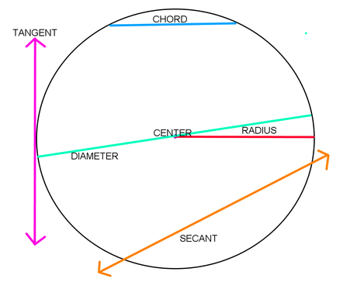
Remember – FOR ALL CLASSES –
to note every 30 minutes!!!
option 1 = do 30 min on each class hw - start with math - then you must move on to another class…then come back if you need to…option 2 = there is no option 2!

Geography 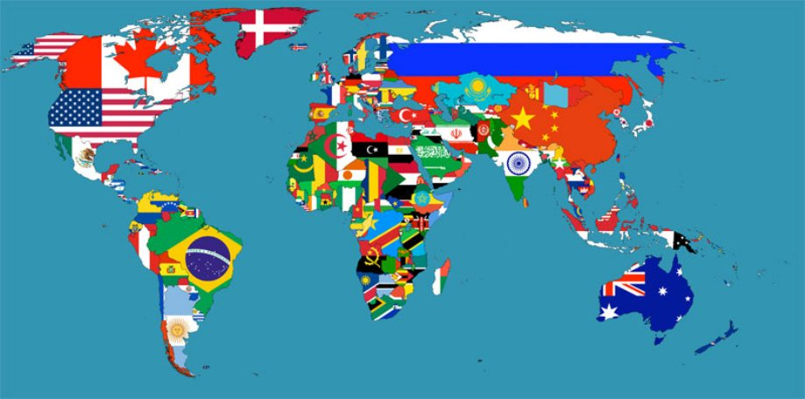
WHERE AM I?
https://geoguessr.com/world/play
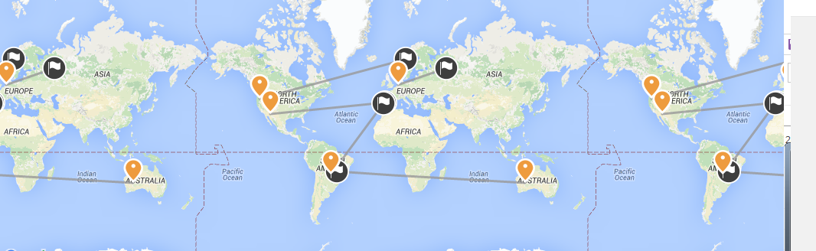
4/29/16 = 9521
YOUR HW WAS: travel journal –
your are going to plan and then write about a tour of Asia for you and 3 friends…starting place…cities you will visit…sites you will tour in each city…and more - today
rough out your travel map…
look at a map of Asia
cover 10 countries…
only one city per country is required…
4/20 = plot your trip! Name each city in each country that you want to visit…10
Due Friday am b4 8 am= plot your trip!
All by yourself
Word doc = list each country in Asia then beside each list the city you want to go to in that country
Word doc = “plot your trip – yourname”
http://www.epicadventurer.com/the-top-15-most-visited-tourist-attractions-in-asia/
top 15 most visited tourist attractions in Asia…
http://www.countryaah.com/Asia.html
list of all countries in Asia…
choose 10 countries/cities
4/22 – HW = TRAVEL JOURNAL
choose 2 sites to see in each city…list the location and facts about each site…
cite all sources…
do in a word doc that you email to me before 8 am Monday am…
doc = sites to see - yourname
ccarroll@sophiaacademy.org
an example of what to do:::
China – Beijing – site: Forbidden City

Forbidden City Facts
Chinese Name: 故宫博物院/ 紫禁城
Chinese Pinyin: Gu Gong Bo Wu Yuan /Zi Jin Cheng
English Name: Palace Museum /Forbidden City
Location: in the center of Beijing
Number of Bays: 8,700
Previous Residents: 14 emperors from the Ming Dynasty, 10 emperors from the Qing Dynasty, and their royal families.
Initiator: Emperor Chengzu of the Ming Dynasty
Designer: Kuai Xiang
Builder: ancient Chinese laborers
Construction Period: 1406 to 1420 in the Ming Dynasty
Main Colors: Red for walls and yellow for roofs
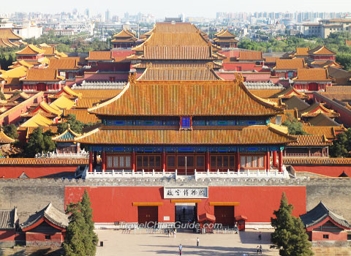
https://www.travelchinaguide.com/attraction/beijing/forbidden-city/facts.htm
image: cite where the image came from

4/25 = get your sites word document fixed
Country + city + site + parag + cite + pic + cite
4/26-5/2 = do your powerpoint – one page for each site that you visit on your tour…due May 2.
Ppt name = “TOUR OF ASIA – YOURNAME”
Ppt page must include:
Country + city + site + parag + cite + pic + cite
Make your ppt interesting.
Make it flow … use slide animation from slide to slide etc…Include sound if you can!
Then – you will write a narration to go along with your ppt presentation – slide by slide – in a word doc.
Narration due May 9…email to me before 8 am Monday.
Ppt = Font is up to you but it must readable.
Narrative = font = time new roman 16
SLIDE 1 = TITLE PAGE
SLIDE 2 = MAP OF YOUR TOUR
SLIDE 3 = YOUR TOUR MATES
SLIDES 4-24 = YOUR TOUR SITES
YOU CAN ADD AN EXTRA SLIDE OF PIC IF YOU GO TO A REALLY COOL SITE!!
**be sure to go through your PPT and make sure pictures don’t cover words and words are not over pictures – if so fix and re-submit asap!!!!!!!
Biology
https://www.youtube.com/watch?v=XOcxhz6Msnk = ANDREA BOCELLI & DAVID FOSTER
HW was = 25.1
4/26 = 25.2
4/27 = vocab puzzle
4/28 = test Monday = study…
Due Monday …
Crosswork puzzle:
- Bilateral
- Cephalization
- Deuterostomes
- Pseudocoelom
- Zygote
- Invertebrate
- Notochord
- Ectoderm
- Mesoderm
- Blastula
- Pharyngeal
- Feedback
- Endoderm
- Chordate
- Radial
- Vertebrate
- Coelom
- Protostomes
=18 answers so – 5 each…
1=book
2=google
3=dictionary

Test Monday on ch 25…
===========================
http://www.pba.org/education/homeworkhotline/
A HOMEWORK HOTLINE…
KHAN…
DR.MATH…
PURPLEMATH…
DREXEL…
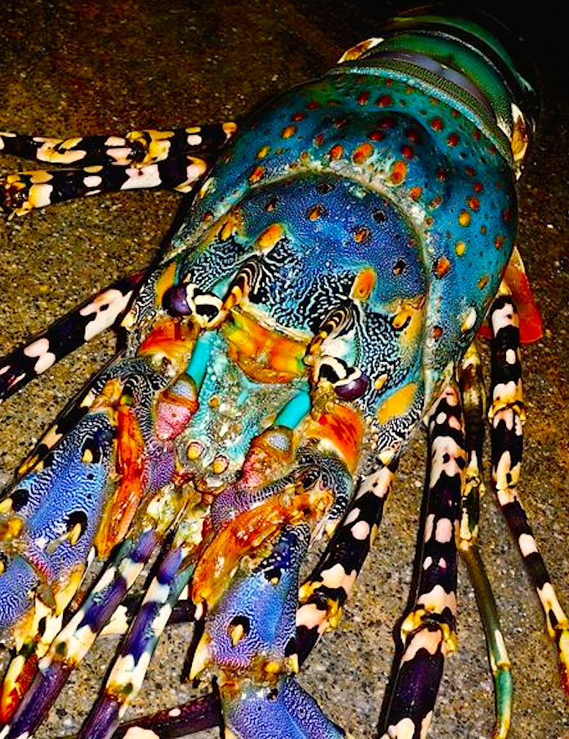Lucy the Lobster says always be ‘prepared’…
With a little clarified butter…hehehe
Leanne the Lemur says …stop whining - do all of your homework!!
And keep that fossa away from me!!!!!!!!!
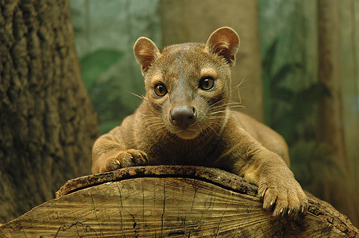Frank the Fossa!

