12th grade – APRIL 28, 2016
6 FLAGS TOMORROW!!!BRING LUNCH OR $20…
*all late/makeup work & corrections must be completed before April 29 for credit.
Math tests are MONDAYS
Science tests are FRIDAYS
Quizzes are any days
TESTS may need to be moved if we are not quite ready…
but that is the exception.
You need to check the weebly every night BEFORE you start your HW!!!!!

PHYSICAL SCIENCE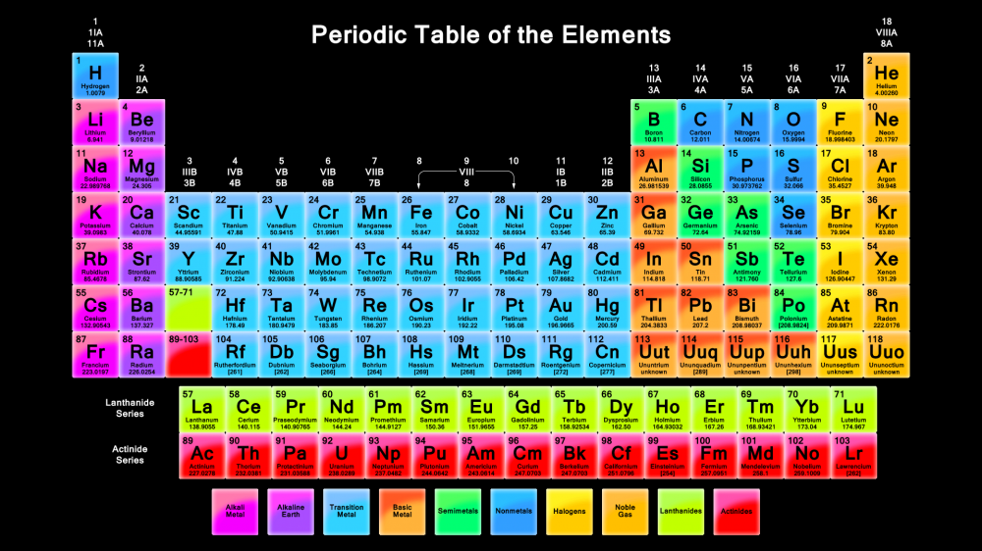
**TAKE NOTES IN YOUR SCIENCE SPIRAL
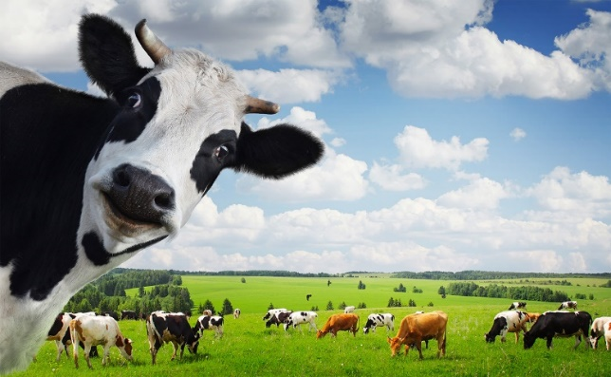

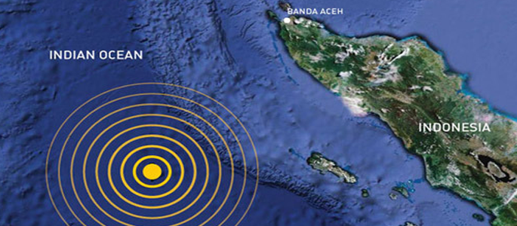

================================================
http://www.conceptualacademy.com/textbook/conceptual-physical-science
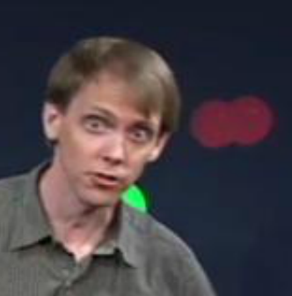I HAVE SOME HW 4 U
4/25 = HW = CH 27 RQ 1-10 DUE TOMORROW – YOU MUST CITE THE PAGE AND PARAG FOR EACH ANSWER…NO CITE = WRONG.
RATS 1-10 DUE FRIDAY
REVIEW QUESTIONS
1. What key evidence did Alfred Wegener use to support his hypothesis of continental drift?
The “jigsaw puzzle” fit of continents at their margins, similar rock types on separated continents, and data from paleoclimatology and paleontology data.
Pg.639 p1 & fig.27.1; pg.640 fig.27.3 & p2;
Pg.639 p2 & pg.640 p1
2. Wegener proposed that the world’s continents had at one time all been joined together into one supercontinent. What was the name of this supercontinent?
Pangaea (Greek for “all lands”).
Pg.639 p2

3. What are glacial striations?
Scrapes and gouges in the land surface (revealing the direction of ice flow) left by moving ice sheets and glaciers.
Pg.640 p2 & fig.27.4

4. Why did the scientific community first reject Wegener’s hypothesis of continental drift?
Wegener did not provide a suitable driving mechanism for crustal movement.
Pg.640 p3

5. Describe how apparent polar wandering helped revive the idea that continents move over geologic time.
The apparent path of polar wandering is different for North American rocks and European rocks. If North America and Europe had been stationary, the polar wander paths would be the same. So it was reasonable to believe that the continents move.
p.641 fig.27.5 and 641 p2-to-642 p1

6. What role did paleomagnetism play in supporting the hypothesis of continental drift?
Paleomagnetism revealed that over time, the position of the magnetic north pole had wandered throughout the world. Either (1) the magnetic poles migrated through time, or (2) the continents had drifted. Movement of the continents was more reasonable. Seafloor spreading was confirmed by magnetic reversals recorded in the seafloor.
p.641 fig.27.5 & p.642 p2 & fig.27.7

7. What did the detailed mapping of the oceans reveal about their topography?
It revealed shallow mid-ocean ridges and deep ocean trenches.
p.642 p.2,3 & fig.27.7 and fig 27.8

8. What was the major discovery of H. H. Hess?
Seafloor spreading—the seafloor is constantly being renewed as rising material from the mantle oozes upward at the mid-ocean ridges. The old lithosphere is simultaneously recycled into deep ocean trenches near the edges of continents.
p.642 fig.27.6 & p.643 p1,2 & mouse

9. How is the ocean floor similar to a gigantic slow-moving tape recorder?
New basalt extruded at the oceanic ridge, is magnetized according to the existing magnetic field. Alternating stripes of normal and reversed polarity on both sides of, and parallel to, the rift areas show the magnetic history of Earth and a continuous record of the movement of the seafloors.
p.644 Fig 27.9 & 27.10

10. In what way does seafloor spreading support the theory of continental drift?
Seafloor spreading initiates the movement of the continents. In a conveyor-belt fashion, new lithosphere is formed at a spreading center and older lithosphere is pushed from the ridge crest to be recycled back into the mantle at a deep-ocean trench.
Pg.644 & fig.27.9 & p2

Rq 11-20

11. The lithosphere moves because of convection currents in the mantle. What causes the convection currents?
Gravity and heat. When rock is heated it rises and expands; it is less dense. Then, as the rock cools and contracts, it becomes more dense. Convection in the hot mantle occurs because gravity pulls the denser rock downward relative to the less-dense rock, which continues to rise upward. The less-dense rock continues to rise to take the place of sinking dense rock pulled downward by gravity. Convection!

12. Describe plate tectonics in one simple statement.
Plates of lithosphere move because of convection currents in the asthenosphere.

13. Name and describe the three types of plate boundaries.
Divergent boundaries—where two plates move apart from one another. Convergent boundaries—where two plates move toward one another. Transform fault boundaries—where two plates slide horizontally past one another.

14. What is a rift? Give an example.
A long, narrow trough that forms as a result of the divergence of two plates. The Mid-Atlantic Ridge and Africa’s Great Rift Valley are two examples.
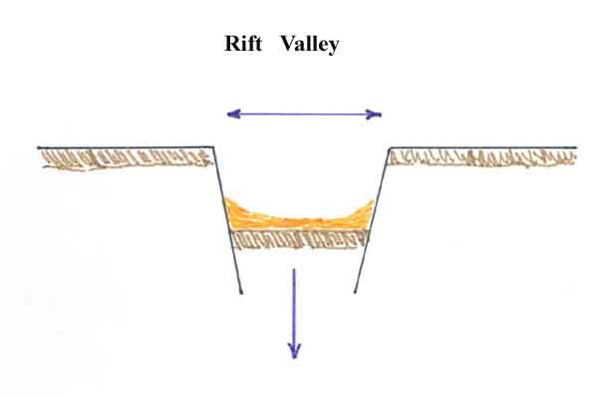

15. Where is the world’s longest mountain chain located?
In the middle of the Atlantic Ocean!
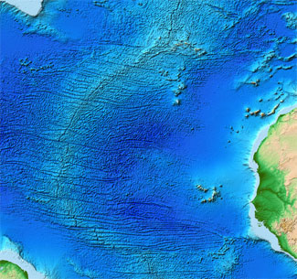
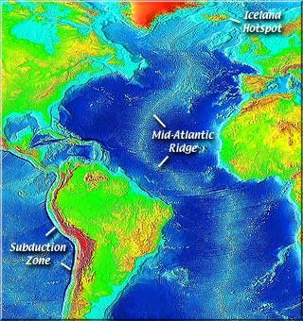
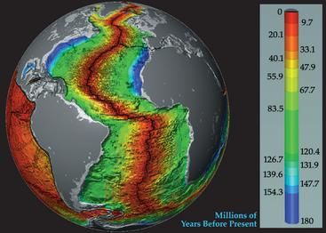
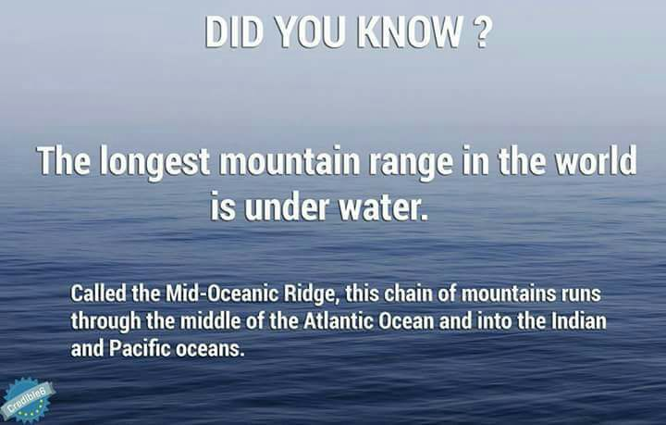
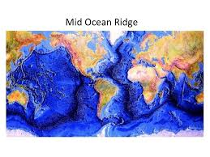
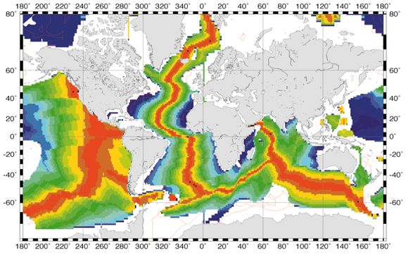
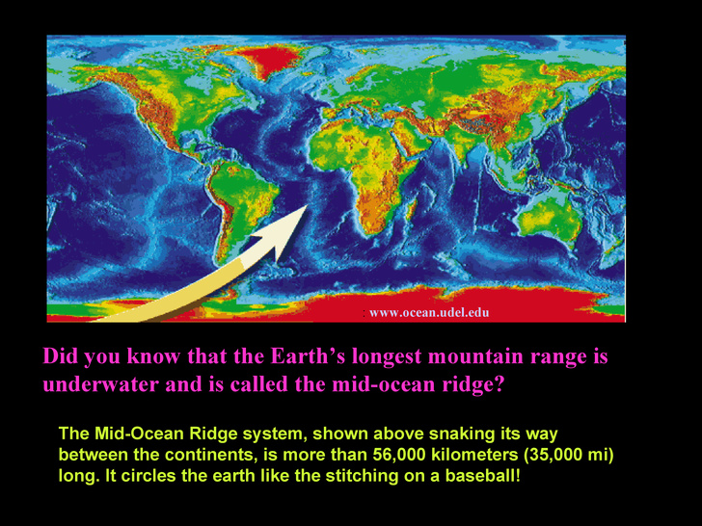

16. In what locations are the deepest parts of the ocean?
The deep-ocean trenches that form at subduction zones.
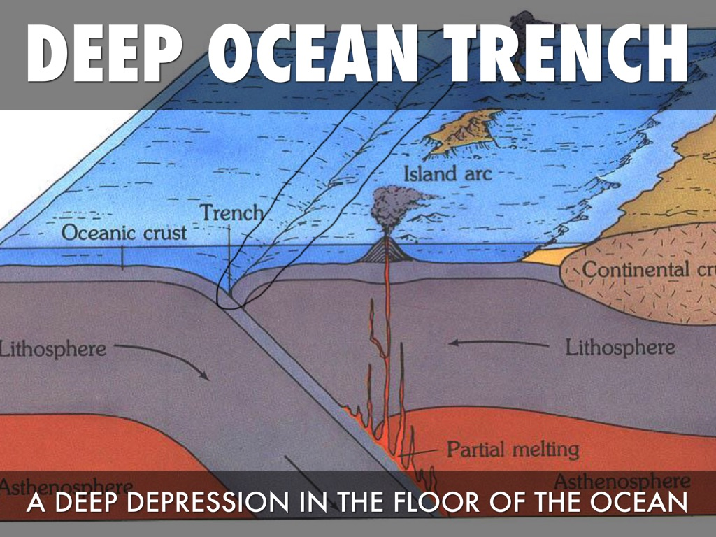
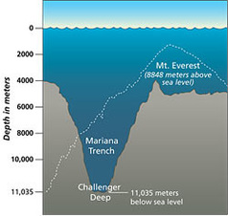
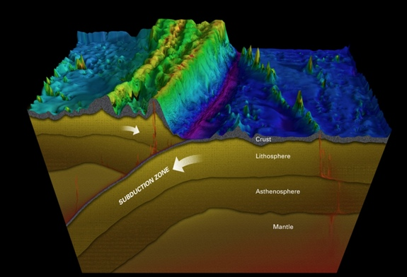

17. What are the three types of plate collisions that occur at convergent boundaries?
Oceanic–oceanic convergence: the subduction of one oceanic plate beneath another at a deep-ocean trench. Oceanic–continental convergence: the subduction of a denser oceanic plate beneath a less-dense continental plate at a deep ocean trench. Continental–continental convergence: the collision of two continental landmasses, with no appreciable subduction.
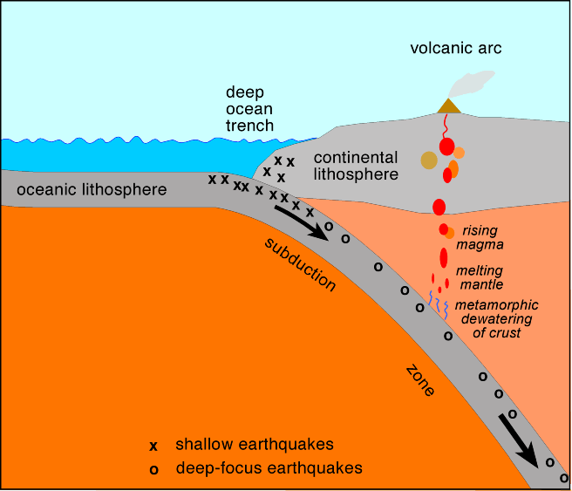

18. What is a transform boundary?
A boundary where two plates are neither colliding nor pulling apart, but rather sliding horizontally past one other.

19. What kind of plate boundary separates the North American Plate from the Pacific Plate?
A convergent boundary coupled with a transform-fault boundary.

20. Cite at least three geologic features that are explained by plate tectonics?
Virtually all geologic processes can be tied to plate tectonics—mountain ranges, volcanoes, plutonic rocks, metamorphic rocks, and folded and faulted rocks.

*HOMEWORK 4/26 = FINISH RQ 11-20
BE SURE TO CITE PG AND PARAG # AND FIGURES WHERE POSSIBLE
*TEST WILL BE MONDAY ON CH 27.
*RATS ARE DUE FRI 8 AM.
Email your rat answers to me by 8 am
Friday morning – going to 6 flags!!
If you email to me by 8 am – I will let you know what the correct answers are…
Just the letter…
Test will be word bank – no spirals.
PreCalculus
MONDAY = TEST DAY
Glogs due Monday…ELSE = 0…BEGINNING MARCH 14, 2016.
HW WAS: 4/25 = redo ws Review of Linear Eq…Redo all that missed or dnd
GRADE ORDER OF OPS WS:
- Turn this in now to me…
Remember – FOR ALL CLASSES –
to note every 30 minutes!!!
option 1 = do 30 min on each class hw - start with math - then you must move on to another class…then come back if you need to…
option 2 = there is no option 2.
YOU NEED TO SET A TIMER FOR 30 MIN.
Precalc = 4/19 = cw = hw = ws “EVALUATING FUNCTIONS” not a boring ws and yet your must do it!!
You must SAW for each problem in your spiral…no work = no credit.
No help at all except textbook & calculator.
Precalc = 4/20 = hw = order of operations worksheet = = saw
No help at all except textbook & calculator.
Precalc = 4/21 = hw = fractions & decimals worksheet = = saw
No help at all except textbook & calculator.
4/25 + 4/26 = redo ws Review of Linear Eq…
Redo all that missed or dnd

======================================
OTHER 12th grade HW IS LISTED BELOW:
LIT = LONE RANGER & TONTO = READ CH & GIVE RESPONSE ON WEEBLY TONIGHT
US HISTORY = N/A
RELIGION = pray & READ ENG REFORMATION
ECON =
Spanish – SPANISH AUTHOR PROJECT = ½ OF FINAL EXAM & ESSAY
SEE ABOVE FILE FOR MATH AND SCIENCE!!!
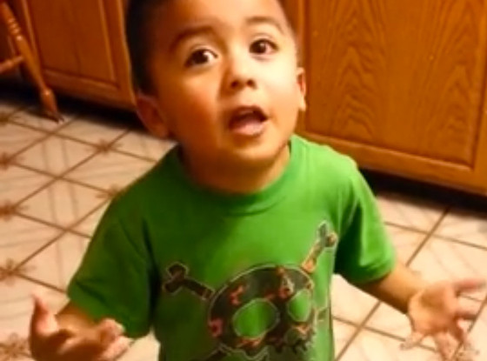MATEO SAYS: DO ALL OF YOUR HW AND DO IT WELL!!!

